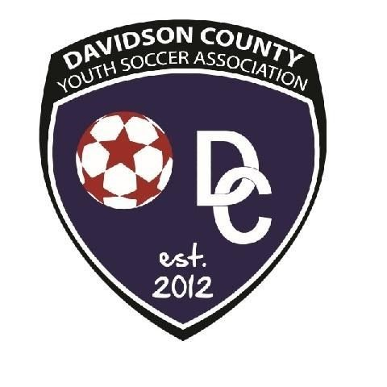Davidson County Youth Soccer Association Fall 2021-Spring 2022
Division
U4- Jan. 1st,2018 to Dec. 31st,2019 | U6- Jan. 1st,2017 to Dec. 31st,2016 | U8- Jan.1,2014 to Dec. 31st, 2015
U10-Jan. 1st, 2012 to Dec. 31st,2013 | U12-Jan. 1st,2010 to Dec. 31st,2011 | U14-Jan. 1st,2008 to Dec. 31st,2009
 | U16-Jan. 1st,2006- Dec. 31st,2007
Jersey: Youth​: Small (6-8)​☐​ Medium (8-10)​☐​ Large (10-12)​☐​ ​Adult​: Small​☐​ Medium​☐​ Large​☐

Player’s Demographics: (​ Must be Legal Name on Birth Certificate)
First Name: | Last Name:
Date of Birth: | Gender:
School: | Grade:
Address:
City/State: | Zip:
Parent/Guardian Information:
 | Name | Home Phone | Mobile Phone | Email
Mother
Father

IMPORTANT MEDICAL AND LIABILITY RELEASE -- MUST BE SIGNED
I (we), the undersigned, residing in the county of, state of NC, the parents/legal guardian of the above Registrant, a minor, who resides with us, do hereby declare our intent to allow that child to practice, train, play and participate in all soccer-related activities with the above mentioned soccer team affiliated with the North Carolina Youth Soccer Association and the United States Youth Soccer Association. I (we) agree that we and the Registrant will abide by the rules of the USYS, its affiliated organizations and sponsors. Recognizing the possibility of physical injury associated with soccer and in consideration for the USYS and NCYSA accepting the Registrant for their soccer programs and activities (the “ Programs”), we hereby jointly and severally release, discharge and/or otherwise indemnify the USYS, NCYSA, their affiliated organizations and sponsors, their employees and associated personnel, including the owners of fields and facilities utilized by the Programs, against any claim by or on behalf of the Registrant as a result of the Registrant’s participation in the Programs and/or being transported to or from the same, which transportation we hereby authorize. I (we) further, jointly and severally, as parents and legal guardians of the Registrant, release, discharge, and agree to hold harmless and indemnify the above-named individuals or any of the designated coaches of the above Team from any and all liability, claims or demands arising from the Registrant participating in the Programs with the above Team specifically to include any and all claims for personal injuries sustained while present or participating in the Programs or traveling to or from events in the Programs or while on trips sponsored by or in conjunction with the Programs. In addition, I (we) do hereby authorize any one of the designated adults of the Team, if after a reasonable attempt has been made to reach a parent or guardian to obtain consent or if sound medical practice decrees that there is not time to make such an attempt, to consent to any x-ray examination, anesthetic, medical or surgical procedure, treatment, and/or hospital care, to be rendered to the Registrant under the general or special supervision of and/or on the advice of any physician, surgeon or dentist duly licensed to practice. The undersigned have read and fully understand and agree to the foregoing.

Name of Insurance Company​: ​_____________________​___​Card and Group#​:_____​_____________

Parent/Guardian Name
Signature & Date
Player is Allergic to these Medications and Substances/ List any Unusual Health Information

***The Zero Tolerance Policy MUST BE SIGNED and on file with DCYSA registrar. The penalty will be that the player will not be placed on DCYSA roster.
Zero Tolerance Policy: A letter to who plan to attend a DCYSL​ game:
To help prevent physical assault and verbal abuse in the leagues and clubs within the Davidson County Youth Soccer League
(DCYSL); the DCYSL has adopted a ZERO TOLERANCE POLICY​. This policy applies to all coaches, players, parents, spectators​ and other supporters and referees effective immediately. Abusive and obscene language, violent play/conduct, fighting and other behavior (including, but not limited to sarcasm, taunting, etc.) deemed detrimental to the game between the above mentioned groups will not be tolerated. The ultimate responsibility for the actions of coaches, players and spectators resides with the member clubs.
It is the responsibility of ALL coaches/players/parents to maintain the highest standards of conduct for themselves, their players and supporters in all matches. Abusive, confrontational and obscene language, violent play/conduct, fighting, inciting, escalating and other behavior detrimental to individuals, the game and the sport will not be tolerated. A coach’s/player’s/parent’s responsibility for referee support and spectator control includes the times prior to, during and after the game at the field and surrounding areas.
All persons responsible for a team and all of the spectators shall support the referee at all times. Failure to do so will undermine the referee’s authority and has the very real potential of creating a hostile environment​ for the players, the referee and all of the other​ participants and spectators. Escalation to violence can easily result​ , t​ herefore:​
No one is to address the referee or make comments on or about a referees call or non-call while present at any Davidson County Youth Soccer League Game.
Exceptions for Coaching Staff or player During Match:​
- Responding to a referee initiating communication.
- Making Substitutions.
- Pointing out emergencies or safety issues. All conversations are to be in a polite, respectful tone of voice. No sarcasm. No​ intimidation.
Exceptions for Coaching Staff or player at Half Time or end of game:
- Ask for an explanation of a call or a rule.
- Polite friendly feedback. All conversations are to be in a polite, respectful tone of voice. No sarcasm. No intimidation.
Coaches, players and/or Parents/Guardian/Spectator: A penalty for unsportsmanlike conduct (Zero Tolerance) shall be assessed whenever a coach, player and/or parents/Guardian/Spectator:
  - Openly disputes or argues about any decision by an Official.
  - Uses obscene or vulgar language, including swearing, in a boisterous manner to anyone at any time, even if it is not directed at any particular person.
  - Visually demonstrates any sign of dissatisfaction with any Official’s decision, in a manner that openly embarrasses the Official and/or challenges his judgment.
  - Uses any type of threatening or derogatory language towards any player, coach, referee, or other spectators. This is at the sole discretion of the referee.
  - Coaches: Does not support and enforce the Zero Tolerance policy, with regards to their players, parent/guardians, or any spectator associated with their team within their control without putting themselves in harm’s way. Any player/parent/guardian/spectator associated with their team that displays unacceptable behavior will be reported to corresponding Travel or Intramural Director immediately. Failure to do so would result in a penalty.
Any time that any coach, player and/or parents/Guardian/Spectators persists in any of these actions, he/she shall be assessed a
Misconduct Penalty. The DCYSL Board of Directors will evaluate the issue to determine what penalty is appropriate and convey their findings and decisions in writing to the player and their parent/guardian. Players have the right to appeal any decision to the DCYSL Board of Directors. Appeals have to be submitted to the Board in writing within 48 hours of being notified of the penalty.
The Davidson County Youth Soccer League may impose additional sanctions upon the offending individual(s) including:
- Suspension or dismissal of coach or player from team position
- Banishment of the offender from participation and or attendance at events
- Banishment of offenders’ family from participation in or attendance at events.

Coach/Parent/Guardian Signature & Date

